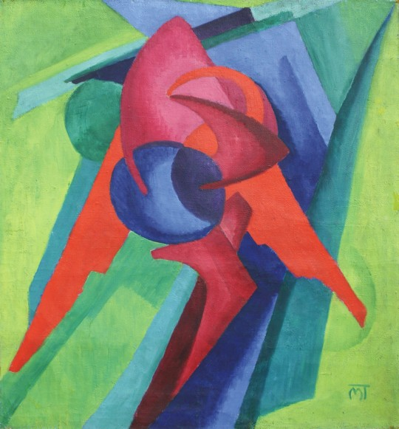
Hans Mattis-Teutsch, Composition, 1925, 136/125 cm, oil on cardboard, The Museum of Visual Arts, Galati, Romania

Mattis-Teutsch, Hans (1884-1960)
Hans Mattis-Teutsch was a Romanian artist, born to a German-Hungarian family in Braşov where he also died. Exemplary for the tortuous modernity in (Central) Europe, he moved like a missionary from peripheries to the centre(s), then back again to periphery, and from traditional realism to Jugendstil, Post-Impressionism, Expressionism, constructive Abstraction, Art Deco, then back again to realism. His stay in Paris in 1905-08 was decisive for his choice of painting, which was influenced by the Fauves, the polychrome sculptures of Paul Gauguin, and Cubo-Futurism but also by the works of Constantin Brancusi, František Kupka, and the Expressionism of Der Blaue Reiter. His stay in Berlin, in 1918, was crucial for his affiliation with Der Sturm. The 99th Sturm exhibition in 1921 featured him and Paul Klee. Like other contemporaries, Mattis-Teutsch extracted stylish-spiritual, cosmic-theosophical visions from fantasised landscapes, then projected innermost psychic workings onto canvases, turned into EEG-like condition reports. He later erected functional-decorative, ideally rational, humanistic edifices based on Socialist utopias, only to end in a ghastly variety of Socialist Realism. Mattis-Teutsch was a keystone of the Romanian, Hungarian and German avant-garde. Though cosmopolitan, he lived mostly in his Transylvanian hometown Braşov, exhibiting locally and working as a professor at the art college, nourishing a modern, progressive provincial art-life. In 1946, he founded the first syndicate of ‘democratic’ artists in Romania.
Mattis-Teutsch started his artistic career learning woodwork in Braşov, he then went to Budapest in 1901, and continued with sculpture studies in Munich in 1903. In 1917, Mattis-Teutsch entered the Budapest-avant-garde circles; his linocut album was first issued by the journal MA. Lajos Kassak introduced him to Herwarth Walden. He also collaborated with the ‘a-z’ group in Cologne and the Bauhaus. Mattis-Teutsch’s Abstract & Expressionist cycle of the 1920s, Seelenblumen (Soulflowers) is a Kandinsky-cum-Marc-like series of buds-patterned figures turned into potent, colourful devices rendering the spiritual, dynamic fusion of natural entities into the painterly mass, losing their descriptive particularities as humans, trees or skies into a purely abstract, rhythmic pulsation, the “musical Expressionism” sought by the artist: “My aim is, by means of painting and sculpture, to create abstract works which can achieve through art a life of their own, one that reflects the states and conditions of the soul.”

In Budapest during the Hungarian Soviet Republic, Mattis-Teutsch was not involved in the political turmoil, but returned to Braşov. In 1920 he had his first solo show in Bucharest. His progression from Expressionism to Constructivism, around 1923-24, coincided with his affiliation to the Bucharest avant-garde. He participated in the First International Exhibition of the journal Contimporanul in 1924, then became a contributor and editor of the Constructivist journal Integral and professor at the Academy of Decorative Arts in Bucharest (a Bauhaus-like institution). Sharing M. H. Maxy’s interests in social art and the “synthetic” (“integral”) human being, Mattis-Teutsch re-introduced, around 1927, human shapes in his works and developed a “constructive Realism”. This Socialist-inspired art-system (in art-practice and theory), backed by his 1931 book, Kunstideologie, which shows the turn from passive to active art, focused on art as order and activism and on the shaping of the ‘New Man’. “I search for a new human type, with no physiognomy; I depict no story, no history, no memory, just the human being as such” he said. From 1933 until the 1940s, Mattis-Teutsch ceased to work, but expressed criticism of Nazism. After 1945 he engaged in the social and political organisation of the artists, yet he became a misfit because of the criticism from Communist officials, who accused him of modernist ‘formalism’. Trying to adapt to Socialist Realism, he resorted to Surrealist-like, figurative portraiture in pale, blurred and wistful settings of propaganda subjects such as workers, peasants, intellectuals, and Stalin.

Readings:

Hans Mattis-Teutsch, Kunstideologie, Stäbilität und Aktivität in Kunstwerk, Bauhausbücher, Potsdam: Müller & J. Kiepenheuer, 1931.

Hans Mattis-Teutsch und Der Blaue Reiter, exh. cat. München. Haus der Kunst, 2001.

Eva Forgacs et al., Janos Mattis Teutsch and the Hungarian avant-garde, West Hollywood, CA: Louis Stern Fine Arts; Budapest: Mission Art, 2002.

Zoltan Banner, Hans Mattis-Teutsch, Bucharest: Kriterion 1974.

